JAVA網路應用#4

工資103 H34996158 侯瑋明

Type1

// BMI1.java

import javax.swing.JOptionPane;

public class BMI1

{

public static void main(String[] args)

{

double BMI = 1.0;

try

{

String firstNum = JOptionPane.showInputDialog("Enter your height(meters):");

String secondNum = JOptionPane.showInputDialog("Enter your weight(kilograms):");

double height = Double.parseDouble(firstNum);

double weight = Double.parseDouble(secondNum);

BMI = weight/ (height*height);

JOptionPane.showMessageDialog(null, "The BMI is " + BMI, "BMI", JOptionPane.PLAIN_MESSAGE);

}

catch(NumberFormatException e) {

System.out.println("Input wring format.");

}

}

}

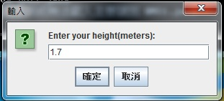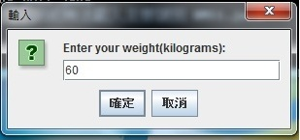

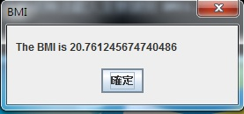

Type2

// BMI2.java

import java.awt.FlowLayout;

import java.awt.event.ActionListener;

import java.awt.event.ActionEvent;

import javax.swing.JFrame;

import javax.swing.JLabel;

import javax.swing.JTextField;

import javax.swing.JButton;

import javax.swing.JOptionPane;

public class BMI2 extends JFrame

{

private JLabel label1;

private JLabel label2;

private JTextField textField1;

private JTextField textField2;

private JButton button;

public BMI2()

{

super("BMI");

setLayout(new FlowLayout());

label1 = new JLabel("Enter your height(meters)");

add(label1);

textField1 = new JTextField(10);

add(textField1);

label2 = new JLabel("Enter your weight(kilograms)");

add(label2);

textField2 = new JTextField(10);

add(textField2);

button = new JButton("Enter");

add(button);

Handler handler = new Handler();

textField1.addActionListener(handler);

textField2.addActionListener(handler);

button.addActionListener(handler);

}

private class Handler implements ActionListener

{

double height =1.0;

double weight =1.0;

public void actionPerformed(ActionEvent event)

{

if(event.getSource() == button)

{

try

{

height=Double.parseDouble(textField1.getText());

weight=Double.parseDouble(textField2.getText());

double BMI = weight/ (height*height);

JOptionPane.showMessageDialog(null,"BMI: " + BMI);

}

catch(NumberFormatException e) {

System.out.println("Input wring format.");

}

}

}

}

}

// BMI2Test.java

import javax.swing.JFrame;

public class BMI2Test

{

public static void main(String[] args)

{

BMI2 frame = new BMI2();

frame.setDefaultCloseOperation(JFrame.EXIT_ON_CLOSE);

frame.setSize(350, 130);

frame.setVisible(true);

}

}

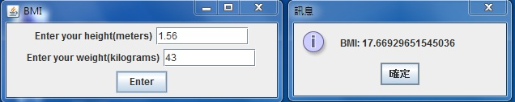

Type3

// BMI3.java

import java.awt.FlowLayout;

import java.awt.event.ActionListener;

import java.awt.event.ActionEvent;

import javax.swing.JFrame;

import javax.swing.JLabel;

import javax.swing.JTextField;

import javax.swing.JButton;

import javax.swing.JOptionPane;

public class BMI3 extends JFrame

{

private JLabel label1;

private JLabel label2;

private JLabel label3;

private JTextField textField1;

private JTextField textField2;

private JButton button;

public BMI3()

{

super("BMI");

setLayout(new FlowLayout());

label1 = new JLabel("Height(meters)");

add(label1);

textField1 = new JTextField(10);

add(textField1);

label2 = new JLabel("Weight(kilograms)");

add(label2);

textField2 = new JTextField(10);

add(textField2);

button = new JButton("Enter");

add(button);

Handler handler = new Handler();

textField1.addActionListener(handler);

textField2.addActionListener(handler);

button.addActionListener(handler);

}

private class Handler implements ActionListener

{

double height =1.0;

double weight =1.0;

public void actionPerformed(ActionEvent event)

{

if(event.getSource() == button)

{

try

{

height=Double.parseDouble(textField1.getText());

weight=Double.parseDouble(textField2.getText());

double BMI = weight/ (height*height);

label3 = new JLabel("BMI: " + String.valueOf(BMI));

add(label3);

}

catch(NumberFormatException e) {

System.out.println("Input wring format.");

}

}

}

}

}

// BMI3Test.java

import javax.swing.JFrame;

public class BMI3Test

{

public static void main(String[] args)

{

BMI3 frame = new BMI3();

frame.setDefaultCloseOperation(JFrame.EXIT_ON_CLOSE);

frame.setSize(160, 220);

frame.setVisible(true);

}

}

